[**3. Mockito Advanced**](blob:https://github.com/37bf0d85-a8c0-425b-a75e-13d27b445eaa) **Outputs**

**Exercise 1: Mocking Databases and Repositories**

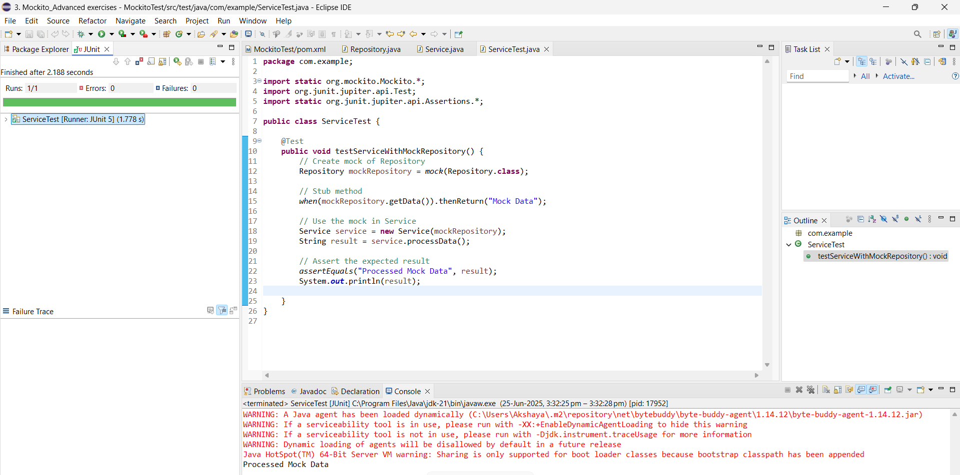

**Exercise 2: Mocking External Services (RESTful APIs)**

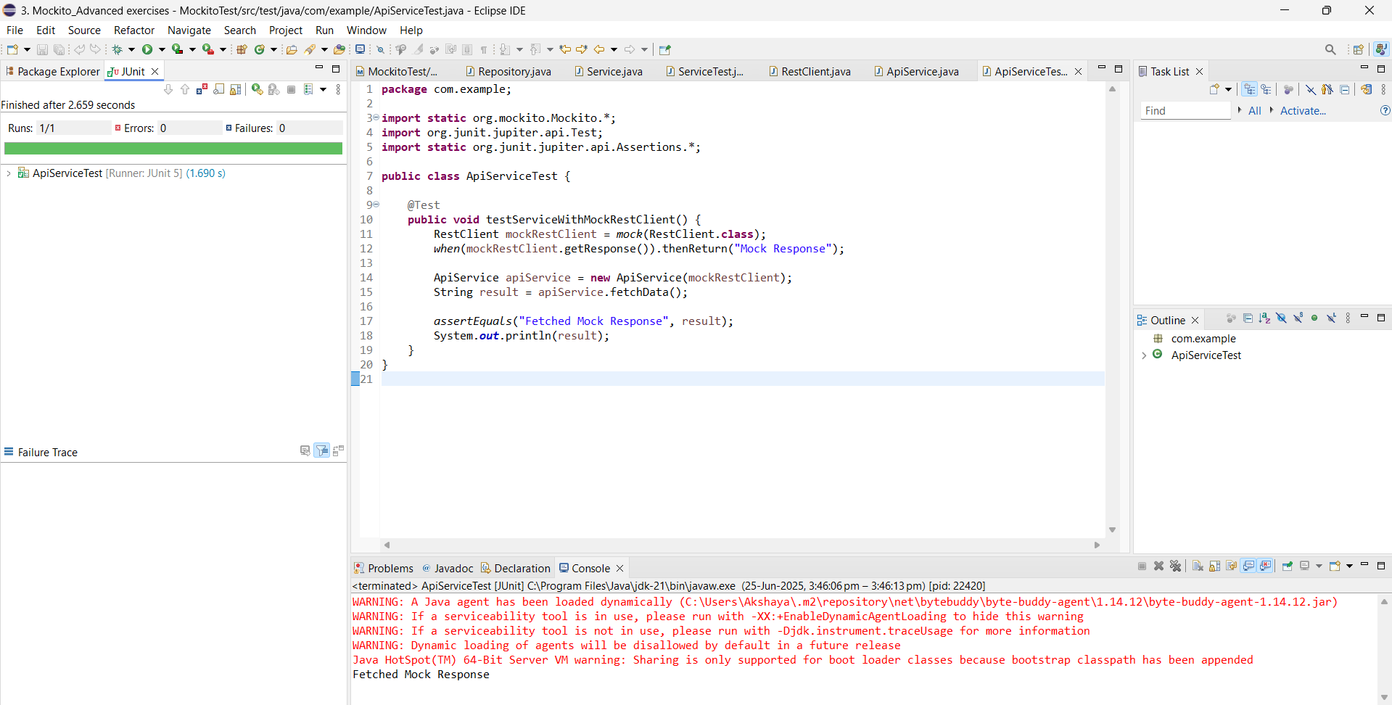

**Exercise 3: Mocking File I/O**

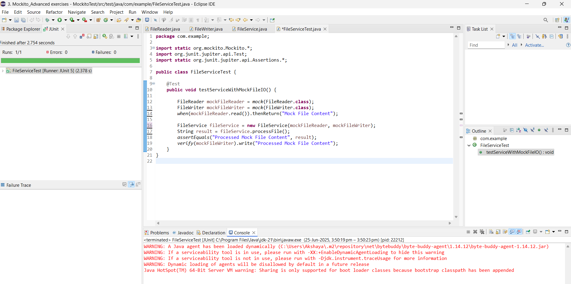

**Exercise 4: Mocking Network Interactions**

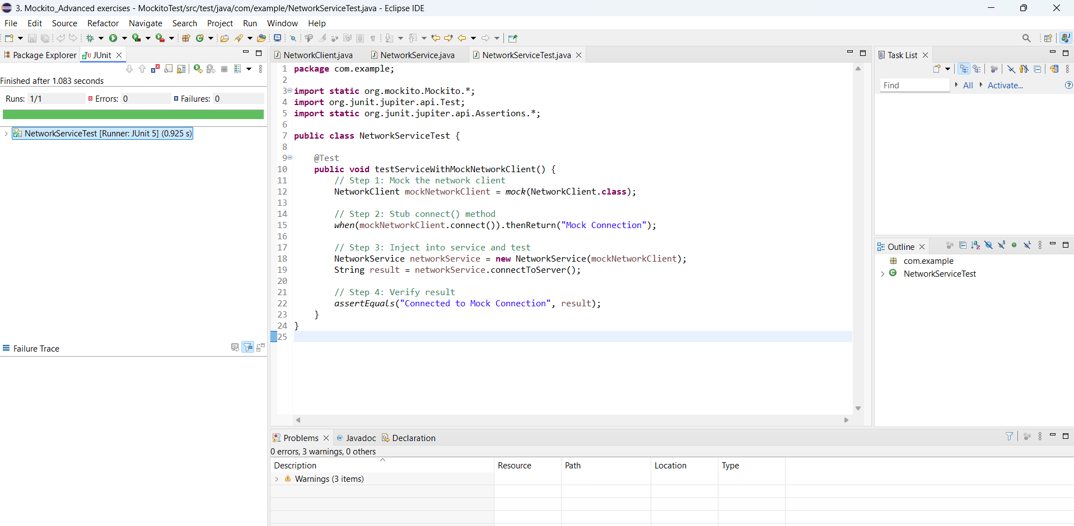

**Exercise 5: Mocking Multiple Return Values**

